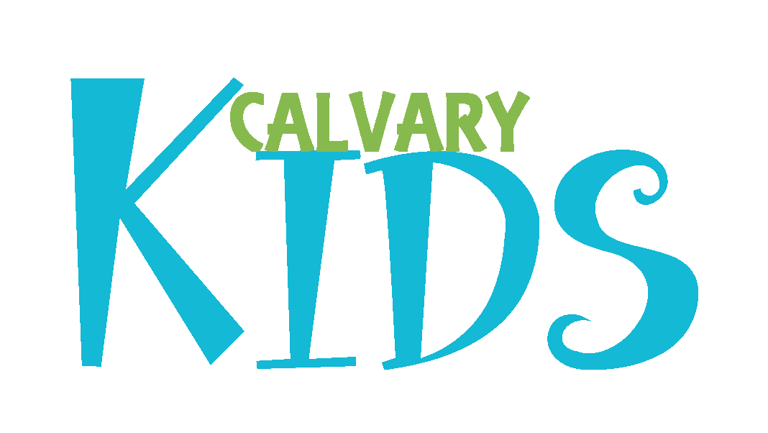

Child & Youth Clearance TEEN Application
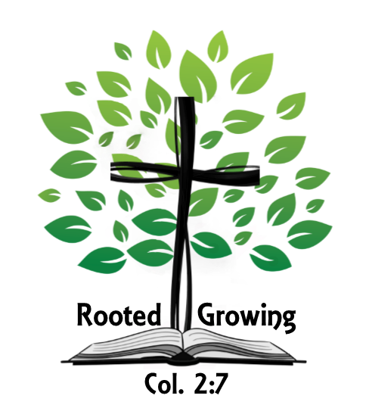

(Revised April 2018)
Effective February 1, 2011

CHILD AND YOUTH ABUSE PREVENTION PROGRAM FOR
CALVARY BIBLE CHURCH

Introduction

To help protect children and youth, Calvary Bible Church has adopted the following Child and Youth Abuse Prevention Program. It is important that all Calvary Bible Church and Shepherd’s Fold Day Care paid staff and volunteers understand and implement these guidelines to help prevent sexual abuse against children and youth. The following document includes the purpose and definitions for these guidelines, the outlines of protection and prevention, a volunteer application and an acknowledgement to be signed by those people working with children and youth.

Purpose

These procedures are designed to reduce the risk of child/youth sexual abuse in order to:

- Provide a safe and secure environment for children, youth, adults, members, volunteers, visitors, and paid staff.

- Assist Calvary Bible Church and The Shepherd’s Fold Day Care in evaluating a person's suitability to supervise, oversee, and/or exert control over the activities of children and youth or to serve with children and youth.

- Satisfy the concerns of parents and staff members with a screening process for all paid staff and volunteers.

- Provide a system to respond to alleged victims of sexual abuse and their families, as well as the alleged perpetrator.

- Reduce the possibility of false accusations of sexual abuse made against volunteers and paid staff.

Definitions

The following terms used herein are defined as follows:

- Paid Staff: Any pastor, minister, director, or employee who is paid a salary or hourly rate, whether employed directly by Calvary Bible Church or The Shepherd’s Fold Day Care.

- Children/Youth/Minor: Any person who has not reached his/her 18th birthday or the age of majority as defined by Pennsylvania state law.

- Adult: Any person who has reached his/her 18th birthday or as defined by Pennsylvania state law.

- Volunteer: Any unpaid person who serves in a capacity that has contact with children/youth or minors, or a person who is involved in activities with and who is entrusted with the care and supervision of minors, or a person who directly oversees and/or exerts control or oversight over minors or adults.

- Sexual Abuse: The employment, use, persuasion, inducement, enticement, or coercion of any minor or adult to engage in, or assist any other person to engage in, any sexually explicit conduct or any simulation of such conduct for the purpose of producing any visual depiction of such conduct or rape, and in cases of caretaker or inter-familial relationships, statutory rape, molestation, prostitution, or other form of sexual exploitation of minor or adult, or incest with a minor or adult, or as defined by federal and state law. This includes and is not limited to unwelcome sexual remarks, jokes, advances, leering, whistling, or sexual gestures; sexual touching, fondling, molestation, assault, or other intimate physical contact; compelling another person to engage in a sexual act by threats or fear or undue influence; and providing or displaying pornographic materials to another person.

- Child Emotional Abuse: Verbal or nonverbal conduct including mental exploitation, degrading communication, or humiliating or threatening conduct that may or may not include bullying or as defined by Pennsylvania state law.

Protection and Prevention

Volunteer and Paid Employee Screening Procedures

The following screening procedures are to be used with paid staff and volunteers. All information collected will be maintained in confidence and kept in a locked, secure location. The assigned representative(s) of Calvary Bible Church will do the following:

- Employment Application and Volunteer Application: All paid staff and/or volunteer (as defined above) who will work with a minor must complete an Employment Application and/or the Volunteer Application. In addition, all paid staff either full time or part time will be required to be screened regardless of what employment position they hold. The release statement attached to the appropriate application must be signed by the individual completing the application to apply for and qualify for service. All documents, clearances, etc. must be finalized prior to serving. The Shepherd’s Fold Daycare also adheres to DHS regulations which allows for TSF staff to sign a disclosure statement stating they have not been accused of a list of allegations and child protection laws which serves in place of the clearances for 60 days.

Our Employment Application will include either an open questionnaire or receipt of a resume as determined prior to the screening and hiring process.

Our Volunteer Application is included in this document and must be filled out completely.

Final page of this document includes a statement, which the applicant will acknowledge in writing, certifying that statements provided in the application are true and complete, and any misrepresentation or omission may be grounds for rejection of the applicant or for dismissal if he or she is employed. This statement authorizes Calvary Bible Church to contact any individual or organization listed in the application and to perform a background check.

- Review all statements made in the application, paying specific attention to any gaps in time and irregular employment patterns or unexplained absence. Pursue these gaps with employers listed and in a subsequent interview.

- Conduct interviews with qualified applicants.

If detrimental information that is circumstantial is uncovered but the applicant remains desirable, discuss this information with the applicant. In the event the applicant is ultimately hired or accepted as a volunteer, document the reasons for overriding the prior information. Final decision on paid staff will be at the discretion of the senior pastor and/or elders. Final decision of volunteers will be at the discretion of the senior pastor in conjunction with the pastor of administration or ministry leader who has direct oversight of that specific ministry and/or elders. All names will be forwarded to the elder board for final review and acceptance. All notations will be documented and names will be recorded in the official elder minutes for permanent record.

- Contact all listed references for volunteers. Contact the volunteer applicant's references and ask for any information that might help determine the applicant's suitability for the position. If a response is not received within a reasonable period of time, follow up and keep notes if possible.

- Contact listed references and employers for paid staff unless discretion at current employer position is required. Inquire as to the reason the applicant left and ask for any information that might help determine the applicant's suitability for the position. If a response is not received within a reasonable period of time, follow up and keep notes if possible.

- Criminal Background Check: Calvary Bible Church will conduct a criminal background check on all paid staff and volunteers using the established format at the time of the application.

- All volunteers will be required to have been an active member of Calvary Bible Church and have reviewed and signed the Child and Youth Abuse Prevention Program Acknowledgement and Release of Information Authorization Sheet. Membership will follow the guidelines established in the Constitution and By-laws of Calvary Bible Church. (See revision page 9)

- Screen assistants: Individuals age 16-17 may serve in the nursery under the supervision of at least two other adult volunteers or paid staff or one adult member and two other properly screened and approved workers who meet the requirements in items #1-7 above. Individuals of at least 13 years of age may serve in the toddler through kindergarten classes under the supervision of at least one other adult volunteer or paid staff who meet the requirements in items # 1-7 above. All assistants must be approved by the Office Administrator before serving.

- Finalize the screening process of all existing paid staff and volunteers (who have not been previously screened) serving at Calvary Bible Church as of March 1, 2011 with a projected completion date of June 1, 2011, and will require all new paid staff and/or volunteers after March 1, 2011 to comply with the screening details as outlined in this document.

Confidentiality

Information obtained through the screening, application, reference check, interview, and criminal background check will be kept in confidence, unless otherwise required by law. All information discovered or obtained through the above referenced means will be kept in a secure location and access to it will be restricted if possible.

Supervision Procedures

Unless an extenuating situation exists, Calvary Bible Church:

- Will have adequate number of screened and trained paid staff or volunteers present at activities involving minors. Supervision will increase in proportion to the risk of the activity. The minimum number present will be two adult members or one adult member and two other properly screened and approved workers.

- Small groups or informal meetings that are not using the 603 Wilson Avenue facility may handle childcare at the discretion of the individuals participating in these meetings. This discretion must comply with the following. They may utilize two adults, a single woman or a teenage girl who is cleared through Calvary’s childcare protection policy. At no time will a teenage boy or male adult be allowed to supervise children alone. All group members will sign a waiver indicating approval of the childcare designate by the group.

- Will monitor facilities during ministries involving minors. Will use premises monitors during the scope of normal ministries at Calvary Bible Church. These monitors will observe the hallways where minors are located as well as view the activity areas through the windows of the doors. NO door windows will be allowed to be covered or concealed under any circumstances.

- Will release minors only to an authorized person in accordance with the established release forms signed by the parent or guardian and following the procedures set forth in the appropriate training manuals.

- Will obtain written parental permission, including a signed medical release form and emergency contacts on an annual basis minimum; in addition to obtaining special release forms prior to taking minors on trips or activities beyond the normal scope of Calvary Bible Church activities.

- Will use a minimum of two paid staff or volunteers when transporting minors in vehicles. One adult in addition to the adult driving.

- Will require that young children, kindergarten age and younger, be accompanied to the restroom by a minimum of two volunteers or paid staff and the paid staff or volunteer wait outside the restroom or in the sink area of the restroom to escort the child back to the activity based upon the needs of the age group. At least one of the escorts will be a screened and approved adult. Whenever possible, the escorts will be the same sex as the minor, however males will never be allowed to escort female children or youth. Will ensure only females will be allowed to change diapers of a child, unless the child is his or her own. Paid staff or volunteers of The Shepherd’s Fold Daycare will adhere to the proper TSF staff guidelines & DHS regulations for the daycare children during daycare hours.

- Will require escorts of young children, kindergarten age and younger who use the restroom area, to have an approved adult enter the restroom to make sure it is safe and that no other adults are present.

- Will screen all paid staff and volunteers and approve those individuals in advance for any overnight activities.

- Will require volunteers to follow guidelines set forth in the various training manuals established and utilized by Calvary Bible Church. Will require paid staff to abide by guidelines established in the staff employee manuals.

- Will require the Family Ministries Pastor and/or Youth Pastor to forward names of all volunteers to the Board of Elders prior to the volunteer’s involvement in ministry and only after they have been properly screened and all documents have been completed and verified.

- Will ensure that the elders hold the paid staff accountable to the policies written in this policy and to ensure the safety and welfare of the children/youth is consistently being monitored.

Behavioral Guidelines for Paid Staff and Volunteers

All volunteers and paid staff will observe the following guidelines:

- Will not provide alcoholic beverages, tobacco, drugs, contraband, or anything that is prohibited by law to minors.

- To the extent possible, all Calvary Bible Church events that are co-educational will have both male and female chaperones.

- Whenever possible, at least two unrelated adult paid staff or adult volunteers will be in the room when minors are present. Doors will be left fully open if one adult needs to leave the room temporarily and/or during arrival to the class or event before both adults are present. Speaking to a minor or minors one-on-one will be done in public settings where paid staff or volunteers are in sight of other people. Pennsylvania state licensed daycares and/or schools operated by Calvary Bible Church will adhere to state regulations with regards to number of paid staff or volunteers required in a room.

- Avoid all inappropriate touching with minors. All touching shall be based on the needs of the individual being touched, not on the needs of the volunteer or paid staff. In the event a minor initiates physical contact and/or inappropriate touching, it is appropriate to inform the minor that such touching is inappropriate.

- Never engage in physical discipline of a minor. Volunteers and paid staff shall not abuse minors in any way, including but not limited to physical abuse, verbal/mental abuse, emotional abuse, and sexual abuse of any kind.

- If any person recognizes an inappropriate relationship developing between a minor and an adult, that person should refer the minor to another individual, leader or any person with supervisory authority and immediately notify a ministry leader of what was observed.

- If one-on-one pastoral care is necessary, avoid meeting in isolated environments. One-on-one pastoral care of a minor will only be done after written permission is received from the minor’s parent or guardian.

- Anyone who observes abuse of a minor will take appropriate steps to immediately intervene and provide assistance. Once this is accomplished, report the inappropriate conduct to the Family Ministries Pastor or another pastor. The leadership of Calvary Bible Church will then intervene and handle in accordance with Pennsylvania state guidelines.

Disqualification

No person (paid or volunteer staff) will be entrusted with the care and/or supervision of minors who has been found guilty of and convicted of the offenses outlined below, been on a probated sentence or received deferred adjudication for any offense outlined below, or has presently pending any criminal charges for any offense outlined below until a determination of guilt or innocence has been made, including any person who is presently on deferred adjudication. Any person who may pose a threat to the children/youth will be prohibited from working in any ministry involving children/youth. Any offenses that are discovered as a result of background checks or reference checks will be reviewed by the senior pastor in conjunction with the pastor of administration and with the paid or volunteer staff person involved.

- Any offense against minors as defined by federal or state law.

- A misdemeanor or felony offense as defined by federal or state law that is classified as sexual assault, indecency with a minor or adult, assault of a minor or adult, injury to a minor or adult, abandoning or endangering a minor, sexual performance with a minor or adult, possession or promoting child pornography, enticing a minor, corruption of minors, bigamy, incest, drug or alcohol related offenses, or family violence.

- A prior criminal history of an offense against minors.

As noted previously…If detrimental information that is circumstantial is uncovered but the applicant remains desirable, discuss this information with the applicant. In the event the applicant is ultimately hired or accepted as a volunteer, document the reasons for overriding the prior information. Final decision on paid staff will be at the discretion of the senior pastor and/or elders. Final decision of volunteers will be at the discretion of the senior pastor in conjunction with the pastor of administration or ministry leader who has direct oversight of that specific ministry and/or elders. All names will be forwarded to the elder board for final review and acceptance. All notations will be documented and names will be recorded in the official elder minutes for permanent record.

Sexual Offender at Calvary Bible Church

Calvary Bible Church may allow a person known to be a sexual offender to become an attendee or a member of the congregation but the offender must adhere to specific guidelines. The first inquiry before attending will be with the offender's probation/parole officer for any restrictions regarding attending services or other functions where minors are present. We will ask the probation/parole officer to put any restrictions in writing. Next, these guidelines will only be implemented after the church’s insurance carrier reviews the policy and does not offer any additional guidelines or restrictions. Finally, if at any time the sexual offender does not adhere to any of these conditions or the probation/parole office prohibits attendance, or the church’s insurance company changes their guidelines, all attendance privileges will be revoked immediately. If restrictions don't prohibit attendance and/or participation, Calvary Bible Church will implement the following guidelines only after the sexual offender signs a “conditional attendance agreement” that will clearly state the points below and will be witnessed by an elder and/or pastor.

- Prior to attending, the offender will meet with the elder board and/or a group designated and given authority by the elder board, at which time the offender will give a history of the details involving the sexual offense. Should the circumstances warrant total exclusion, that decision will be finalized and made known to the offender. Reasons may include, but not be limited to, situations where the offender’s victims or family attend the church, a recent history of repeat offenses, etc.

- The offender must always be accompanied by a designated chaperone while on church property for any reason. This includes, but is not limited to, religious services, educational and elective study classes, ministry activities, restroom breaks, prayer meeting and office visits.

- The chaperone will be an active member of Calvary Bible Church that has been preapproved by the elder board based on the offender’s gender and past history.

- The chaperone will meet the offender at the entrance door and remain with the offender until he or she returns to their vehicle and leaves the premises.

- The offender cannot participate in any of the children or youth ministries or programs whether conducted on Calvary Bible Church property or at a site being used by Calvary Bible Church.

- The offender may never be on the upper parking lot or second floor of the facility where The Shepherd’s Fold Day Care operates.

- The elder board of Calvary Bible Church has the authority to revoke any attendance privileges at any time.

- An independent background check will be conducted by Calvary Bible Church at any time during the offender’s attendance and prior to membership.

- The offender will not be allowed to serve as a paid employee of Calvary Bible Church or The Shepherd’s Fold Day Care or serve as a volunteer in any ministry that involves the direct contact with children/youth.

- The identity of the offender will be disclosed to the membership of Calvary Bible Church as well as the teachers and parents of The Shepherd’s Fold Day Care. The restrictions in point’s #1-9 will also be disclosed to the members, teachers and parents.

Response to Sexual Abuse

Calvary Bible Church will respond promptly to investigate any accusation of sexual abuse. All accusations of sexual abuse will be taken seriously. It is important to be appropriately respectful to the needs and feelings of those who allege sexual abuse and those who have been accused of sexual abuse.

When an allegation is made involving sexual abuse, the person reporting the complaint is to be told about the guidelines and the procedures to be followed. The senior pastor or an appointed person will begin investigating the allegations and may use the assistance of legal counsel or other consultants. If the senior pastor is the individual accused of sexual abuse, then the president of the elder board will conduct the investigation. The investigation will be conducted as follows:

- Report the matter to Calvary Bible Church’s legal representative within 24 hours of any allegation or suspicion of child abuse or neglect that has been reported to a ministry leader and, if time and circumstances permit, obtain a written opinion concerning how to proceed. After consulting with a legal representative, and in a reasonable amount of time in accordance with insurance company regulations, contact Calvary Bible Church’s insurance carrier.

- Report the incident to appropriate authorities in accordance with the Pennsylvania state mandatory reporting laws after receiving written opinion from a legal representative.

- Cooperate with authorities and the insurance carrier.

- Calvary Bible Church may suspend (with pay for paid staff) the alleged offender while a confidential investigation is being conducted.

- An appointed official of Calvary Bible Church (and legal counsel or other consultants, as deemed necessary) will then meet with the elder board of Calvary Bible Church and present a report on their investigation, which will include findings and recommendations of actions.

- An appointed official of Calvary Bible Church will meet with the alleged perpetrator and notify him/her of the results of the investigation and recommendations for actions.

- An appointed official of Calvary Bible Church will meet with the alleged victim, along with his/her parents or guardians, and notify them of the results of the investigation and recommendations for actions.

- During the investigation, an appointed official of Calvary Bible Church will maintain contact with the alleged victim and his/her parents or legal guardian, and inform them of the actions taken and assist them in their process of healing.

- An appointed official of Calvary Bible Church (and legal counsel or other consultants) may meet with the alleged perpetrator, the alleged victim, and any others with knowledge of relevant facts.

- Communicate with criminal and civil legal counsel obtained by Calvary Bible Church as required or as deemed necessary.

- Communicate with those affected by the ministry of the alleged perpetrator, at the same time recognizing that keeping the sphere of information disclosed is to be to a minimum of people.

- Hire a consultant or assign a spokesperson to respond to media or prepare a statement for the media if the need shall arise, subject to the approval of Calvary Bible Church’s attorney, legal counsel or the insurance company.

Revision page 3, paragraph 7 added July 12, 2012

"Approval as a teen helper under this policy and meeting all the requirements of this policy for the entire sixth months prior to turning 18 may be used to satisfy the sixth month waiting period for any person who applies for membership prior to their 19th birthday."

Revision page 3, paragraph 7 changed July 27, 2016

Removal of 6 month waiting period per Elder approval on July 14, 2016
Children’s/Youth Ministries Volunteer Application
For Teen Workers

Thank you for your interest in Children’s Ministries at Calvary Bible Church. We desire to provide a safe, nurturing, Christ-centered environment that stimulates children to thirst for God, His Word and come to know Jesus Christ as personal Savior and Lord. We believe your desire to serve in this ministry demonstrates that you feel as we do, that children are a top priority. Because they are, and due to the overwhelming tide of child abuse and litigation in America, we are requesting that each teen volunteer working with children, fill out this entire questionnaire. This not only protects our children, but reduces the possibility of false accusations against you and our church body. The contents of this questionnaire will be kept confidential and used only for its stated purpose as outlined in the content of the above Child and Youth Abuse Prevention Program.

PERSONAL INFORMATION

Name __________________________________
Address _________________________________ Date of Birth ________________________
City ____________________________________ Phone: Home _______________________
State ______ Zip _____________ Cell _______________________________
How long have you lived at this address? ___________ E-mail _____________________________
Have you lived in the state of Pennsylvania for 10+ consecutive years? __________________________
Previous address(es) if less than 10 years: __________________________________________________
____________________________________________________________________________________

**Driver’s License Number: _______________________ State: ______ Expiration: _______________
Have you had any accidents or moving violations in the past 5 years? ___________________________
If yes, please explain: _________________________________________________________________
___________________________________________________________________________________
___________________________________________________________________________________
**If applicable
Please complete all sections, sign and return to the Office Administrator 3 weeks prior to serving in CBC Children’s/Youth ministry to allow adequate time for processing your paperwork and obtain appropriate clearances needed.

Area(s) of ministry you desire to serve: ______________________________________________
Would you be willing to serve a minimum of one year in this area of ministry? ______________
Have you had any special training or experience that equips you for this area of ministry?
If yes, please explain:

EMPLOYMENT HISTORY (If applicable)
Present Employer: ______________________________________________________________

Address: ______________________________________________________________________

City: _____________________________________ State:__________ Zip: ________________

Work Phone Number (if you can receive calls) _______________________________________

How many jobs have you had in the last 3 years? ____________

REFERENCES

Please list 3 references (2 must be non-family) that are qualified to speak of your spiritual experience, Christian service, and past interaction with minors. Please list your relationship, if any, to the person.

Name Complete Address Email Phone #
Last:  First: |  |  | (H)  (C) | How long have you known them?
Last:  First: |  |  | (H)  (C) | How long have you known them?
Last:  First: |  |  | (H)  (C) | How long have you known them?

PERSONAL HISTORY
Have you ever participated in, been accused of, convicted of or pleaded guilty or no contest to abuse or sexual misconduct? Yes _____ No ______

Have you ever been convicted of or pleaded guilty or no contest to any criminal offense of any kind? Yes_____ No _____

If yes to either question above, please indicate the nature of the offense, date, court and disposition:

Are you aware of any traits or tendencies you possess that could pose any threat to children or youth? Yes _____ No _____

If yes, please explain:

CHURCH INFORMATION

Date you became a member of Calvary Bible Church: Requirement waived until age 18

How long have you been attending Calvary Bible Church? ___________

List previous ministries that you have been involved with in the past five years:

List previous churches you attended regularly in the past five years:

Any comments you would like us to know about you that would assist us in making a decision concerning your involvement in children/youth ministries at Calvary Bible Church?

Child and Youth Abuse Prevention Program Acknowledgment

and Release of Information Authorization for Teens

These guidelines have been designed to guide and assist you when working with minors. This information establishes general practices and guidelines and should not be construed in any way as a contract of employment or continued employment in either a paid or volunteer capacity. Calvary Bible Church reserves the right to make changes in the content or application of this program and to implement those changes with or without notice.

The terms listed herein are defined for the purposes of this program only. These terms are not defined for the purposes of creating a legal relationship with Calvary Bible Church or any related or associated entity and instead are to be used within this document in order to clarify and define classifications or groups of people.

My signature below signifies I have received a copy of the Calvary Bible Church’s Child and Youth Abuse Prevention Program. In addition, I understand it is my responsibility to become familiar with and adhere to the information contained herein and as may be amended hereinafter from time to time. I understand that a brief renewal application may be required annually or at the discretion of the leadership and I agree to submit all documents within the time frame required.

The information contained in this application is true and correct to the best of my knowledge, information and belief and has been filled out personally by the person listed below. I authorize any background checks, references, criminal background checks and churches to give you any information (including opinions) that they may have regarding my character, past history and fitness for children’s/youth work. In consideration of the receipt and evaluation of this application by Calvary Bible Church, I hereby release any individual, church, children/youth organization, charity, employer, reference, or any other person or organization, including record custodians, both collectively and individually, from any and all liability for damages of whatever kind or nature which may at any time result to me, my heirs, or family, on account of or as a result of compliance or any other attempts to comply, with this authorization.

___________________________ X____________________________ _____/_____/_____
Print Name Signature Date

To be completed and signed by parent/guardian of teen applying to serve. As the parent/guardian of the above mentioned teen, we recognize he/she is under our authority and he/she has offered to help with children and as their parent/guardian we grant permission for him/her to serve and for Calvary Bible Church to complete the screening process.

______________________________ X ________________________________ _____/_____/_____
Parent/guardian name (please print) Signature of parent/guardian Date

Please return completed pages 10-13 to the Office Administrator within 3 weeks prior to serving in CBC Children’s/Youth Ministry.

--------------------------------------------------------------------------------------------------------------------------------------------
Do not write below this line

Background information reviewed ____________________
Comments:

